

P828SP License Plate Recognition Product Introduction

Product Overview
The AK-P828SP is a license plate recognition all-in-one machine designed specifically for unmanned parking management. It features a simple, exquisite, and compact design. The device integrates a high-definition license plate recognition camera, a four-line high-brightness LED display, and intelligent voice control. It supports license plate recognition, dynamic scanning of vehicles without license plates for entry and exit, and the displayed information can be freely configured.

Product Images
注：产品以实物为准，图片仅供参考
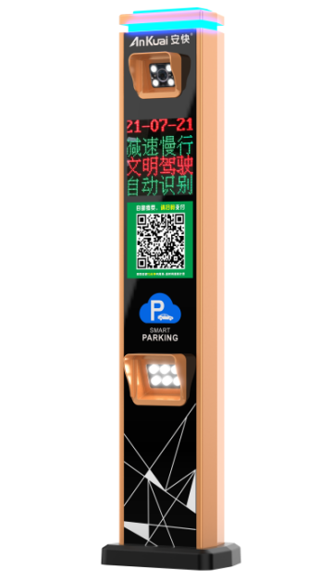

Target customers
Engineering companies, communities, shopping malls, hotels, parking lots, enterprises and institutions, etc.

Use cases
- Community access control
- Shopping mall parking management
- Hotel vehicle access management
- Parking automation management

Core Functions
- It uses a 500W high-definition license plate recognition camera .
- It uses a dedicated license plate recognition chip , which has powerful and stable performance .
- It uses a four-line high-brightness LED display, and the displayed information can be freely set.
- Supports deployment methods for both public and local area networks .
- Supports remote cloud-based operation and maintenance .
- Supports turning the fill light on /off according to the ambient light level .
- It supports vehicles without license plates to enter and exit the parking lot by scanning a code and to make self-service electronic payments in the parking lot .
- It supports user-friendly voice prompts and on-screen display prompts .

Key selling points
Chassis Design | - Its appearance is simple, exquisite and compact.
Appearance and craftsmanship | - It adopts automotive paint technology, resulting in superior quality.  - Durable and can be used outdoors for more than 3 years.  - The design is simple and elegant.
Camera | This 500W high-definition license plate recognition camera can recognize various license plates, including blue plates, yellow plates, new energy vehicles, police cars, military vehicles, new armed police vehicles, Guangdong-Hong Kong/Guangdong-Macau license plates, new embassy license plates, training vehicles, civil aviation license plates, emergency vehicle license plates, and special license plates .
Display screen | The four-line high-brightness LED display screen allows for customizable information display settings.
Electronic control section | Electronic components are assembled using a single-board control system, making maintenance simple.

Technical parameters
Operating voltage | AC220V
Operating ambient temperature | -25℃~70℃
relative humidity | ≤85%, no condensation (at room temperature)
Display screen | Four rows of high-brightness LED display screen
Screen size | 192*192mm
Camera | 500W camera module
License plate recognition rate | ≥99.9% (24/7)
Special license plate recognition rate | ≥95% (all day)
Communication methods | TCP/IP
Input Interface | 6 USB 2.0 ports, RS485, ground loop input, MIC interface, etc.
Protection level | IP54
External dimensions | 320*236*1395mm

competitive advantage
1 | A 500W high-definition license plate recognition camera with high recognition accuracy.
2 | The four-row high-brightness LED display screen allows for customizable information settings .
3 | Single-board control, simple and convenient maintenance.
4 | The combination of colorful lights and a PC lampshade creates a soft yet eye-catching glow.
5 | The company has an automated paint baking line that uses automotive paint baking technology, ensuring that the equipment will not peel off within 3 years.
6 | The total power consumption is less than 70W, and the supplementary light is controlled by a light sensor and the seven-color light circuit board is controlled, which is energy-saving and environmentally friendly.
7 | The QR code sticker has LED lighting, making it effective for nighttime use.

